*Code with output*

1. Linear, Multiple and Quadratic Regression

**Code**

#install ggiraphExtra package

library(ggplot2)

library(plyr)

library(ggiraphExtra)

report_r=read.csv("D://sem3 materials//labs//R programming//lab_project//water_data.csv")

report_r=report_r[,c(4:11)]

report_r=na.omit(report_r)

#DO

lm1<-lm(DO~Temp+BOD,data=report_r)

summary(lm1)

a=data.frame(Temp=29.2,BOD=1.5)

result=predict(lm1,a)

result[1]

ggPredict(lm1,se=TRUE,interactive=TRUE)

lm_do=lm(DO~.,data=report_r)

summary(lm_do)

a=data.frame(Temp=29.2,PH=6.3,CONDUCTIVITY=100,BOD=1.5,NITRATE=0.1,F_COLIFORM=7942,T_COLIFORM=13575)

result=predict(lm_do,a)

result[1]

#CONDUCTIVITY

#linear

lm2<-lm(report_r$CONDUCTIVITY~report_r$PH)

summary(lm2)

a=data.frame(PH=7.5)

result=predict(lm2,a)

result[1]

ggplot(report_r,aes(y=CONDUCTIVITY,x=PH))+geom_point()+geom_smooth(method="lm")

#Polynomial(Quadratic) regression

x1<-(report_r$PH)^2

qm<-lm(report_r$CONDUCTIVITY~x1+report_r$PH)

summary(qm)

a=data.frame(PH=7.5)

result=predict(qm,a)

result[1]

ggplot(report_r,aes(y=CONDUCTIVITY,x=PH^2+PH))+geom_point()+geom_smooth(method="lm")

#NITRATE

#multiple regression

lm3<-lm(report_r$NITRATE~report_r$F_COLIFORM+report_r$T_COLIFORM)

summary(lm3)

a=data.frame(F_COLIFORM=11,T_COLIFORM=27)

result=predict(lm3,a)

result[1]

**Output**

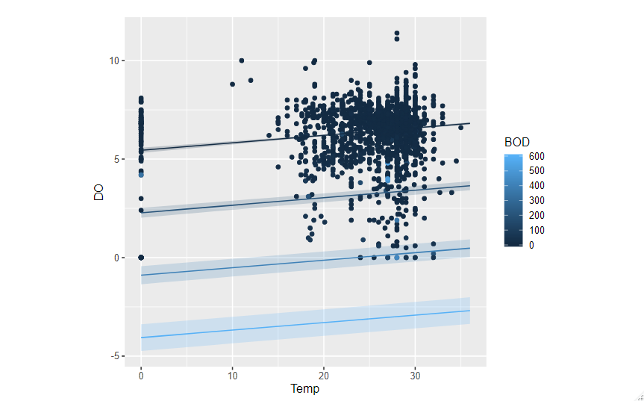

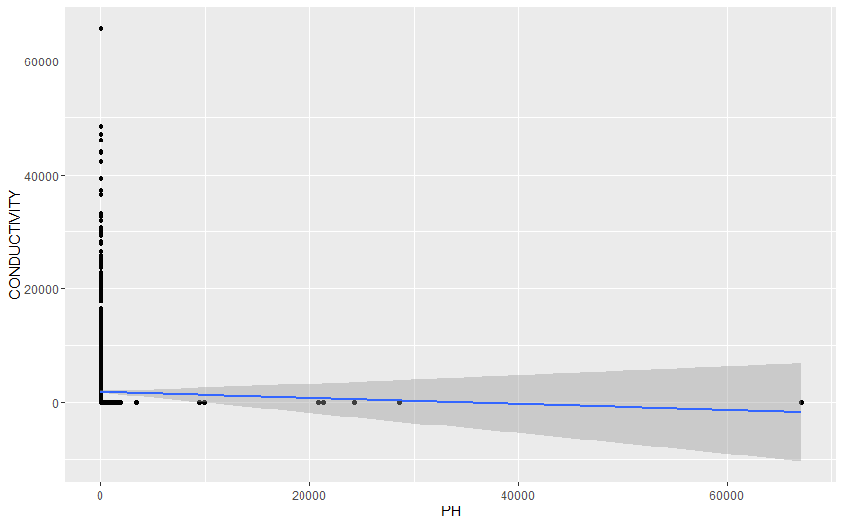

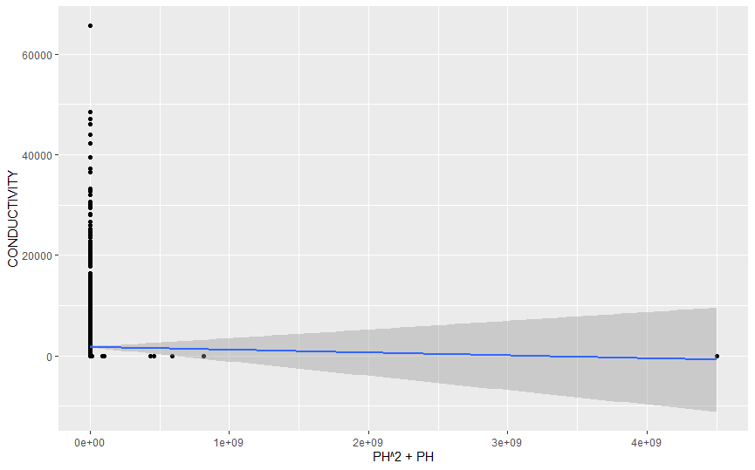

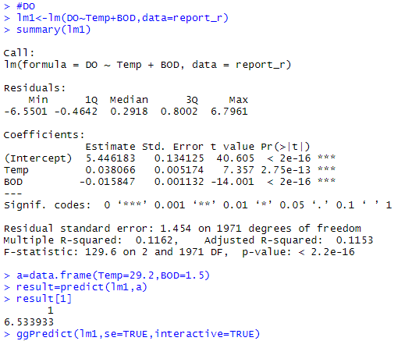

#calculating D.O.  considering all factors

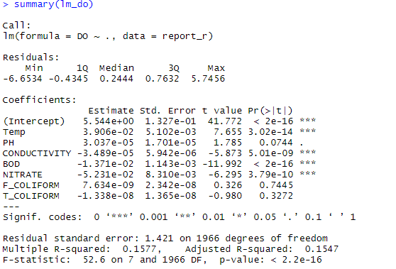



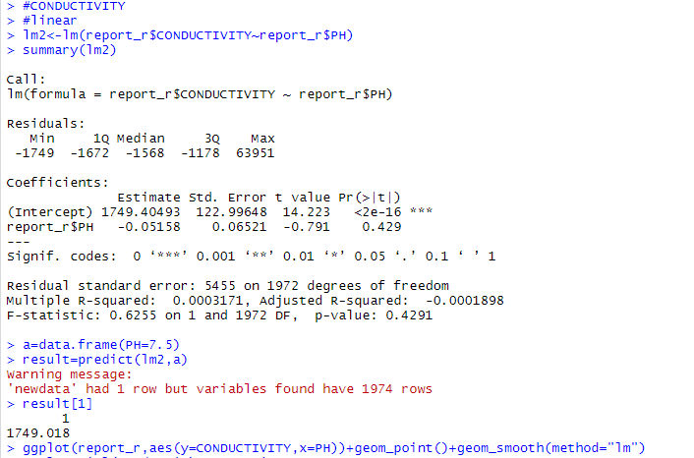

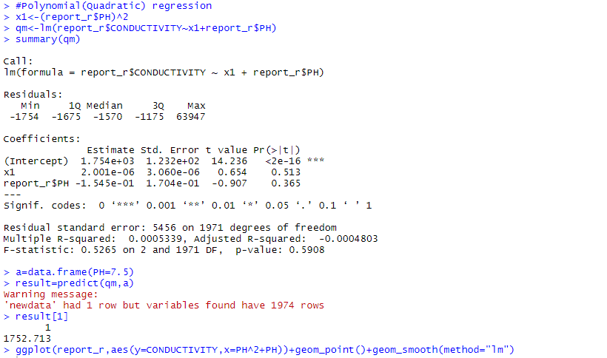

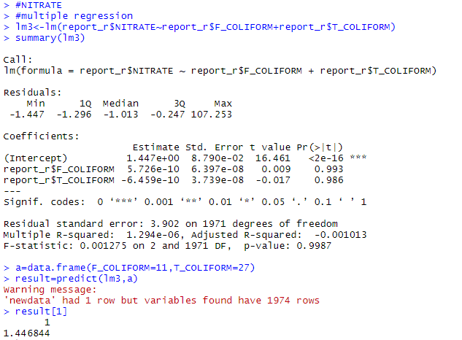

1. Stepwise Regression(Also, forward selection and backward elimination)

**Code**

report_r=read.csv("D://sem3 materials//labs//R programming//lab_project//water_data.csv")

report_r=report_r[,c(4:11)]

str(report_r)

report_r=na.omit(report_r)#to remove null values nan

#both direction

Report_model=step(lm(DO~.,data=report_r),direction="both")

Report_model

a=data.frame(Temp=29.2,PH=6.3,CONDUCTIVITY=100,BOD=1.5,NITRATE=0.1,F_COLIFORM=7942,T_COLIFORM=13575)

result=predict(Report_model,a)

result

#forward direction

Report_model_for=step(lm(DO~1,data=report_r),direction="forward",scope=~ Temp+PH+CONDUCTIVITY+BOD+NITRATE+F_COLIFORM+T_COLIFORM)

Report_model_for

a_for=data.frame(Temp=29.2,PH=6.3,CONDUCTIVITY=100,BOD=1.5,NITRATE=0.1,F_COLIFORM=7942,T_COLIFORM=13575)

result_for=predict(Report_model_for,a)

result

#backward direction

Report_model_back=step(lm(DO~.,data=report_r),direction="backward")

Report_model_back

a_back=data.frame(Temp=29.2,PH=6.3,CONDUCTIVITY=100,BOD=1.5,NITRATE=0.1,F_COLIFORM=7942,T_COLIFORM=13575)

result_back=predict(Report_model_back,a)

result_back

**Output**

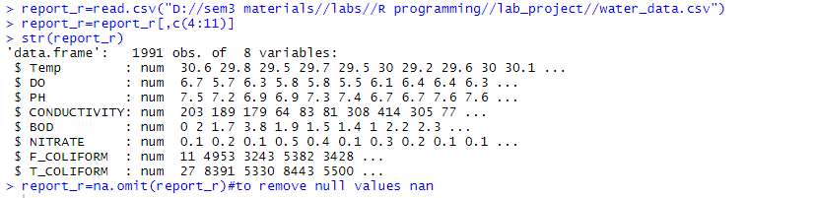

Stepwise regression

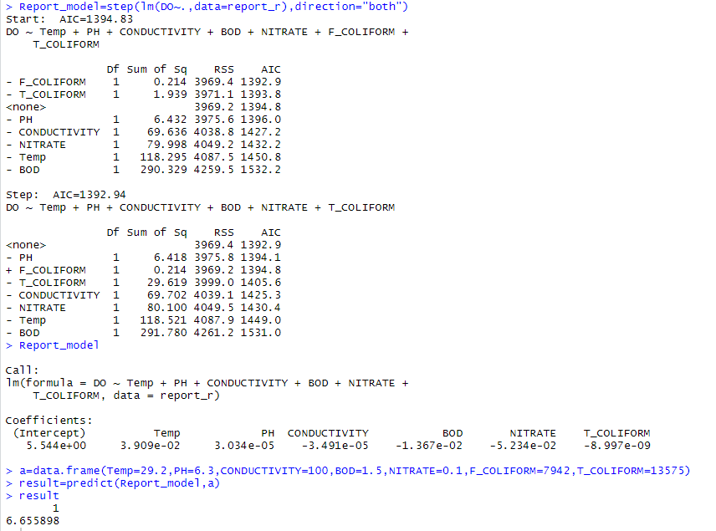

Forward selection

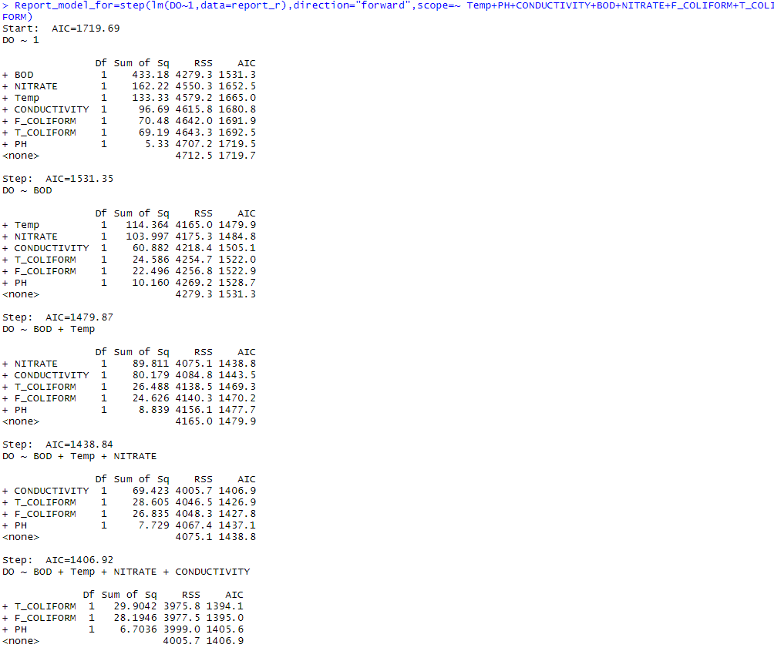

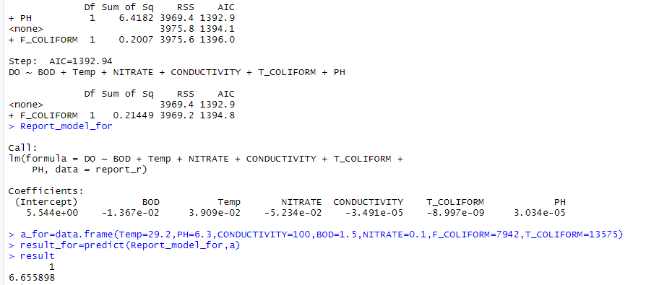

Backward elimination

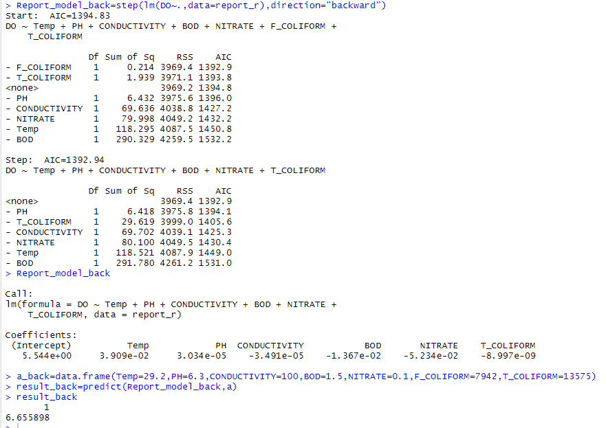

1. Ridge, Lasso, and Elastic Net Regression

**Code**

library(glmnet)

library(tidyverse)

library(caret)

report_r=read.csv("D://sem3 materials//labs//R programming//lab_project//water_data.csv")

report_r=report_r[,c(4:11)]

report_r=na.omit(report_r)

#partition

set.seed(103)#The seed number (n) you choose is the starting point used in the generation of a sequence of random numbers

ind=sample(2,nrow(report_r),replace=T,prob=c(0.8,0.2))

ind

train=report_r[ind==1,]

test=report_r[ind==2,]

str(test)

#DO with BOD and temp

x=model.matrix(DO~BOD+Temp, train)[,-1]

y=train$DO

cv = cv.glmnet(x, y, alpha = 0)

cv$lambda.min

Ridge_model = glmnet(x, y, alpha = 0, lambda = cv$lambda.min)

Ridge_model

summary(Ridge_model)

coef(Ridge_model)

#predictions

x_test = model.matrix(DO~BOD+Temp, test)[,-1]

result_rid = Ridge_model %>% predict(x_test) %>% as.vector()

#single value prediction

5.65026689+-0.01540126*1.5+0.03136930*29.2

cv = cv.glmnet(x, y, alpha = 1)

cv$lambda.min

Lasso_model = glmnet(x, y, alpha = 1, lambda = cv$lambda.min)

Lasso_model

summary(Lasso_model)

coef(Lasso_model)

#predictions

x_test = model.matrix(DO~BOD+Temp, test)[,-1]

result_las = Lasso_model %>% predict(x_test) %>% as.vector()

#single value prediction

5.61717393+-0.01712410*1.5+0.03311161*29.2

Elastic_net= train(DO~Temp+BOD,data=train,method="glmnet",trControl=trainControl("cv",number=10),tuneLength=10)

Elastic_net_model = glmnet(x, y, alpha = Elastic_net$bestTune$alpha, lambda = Elastic_net$bestTune$lambda)

summary(Elastic_net_model)

coef(Elastic_net_model)

#predictions

x_test = model.matrix(DO~BOD+Temp, test)[,-1]

result_elas = Elastic_net_model %>% predict(x_test) %>% as.vector()

#single value prediction

5.68355435+-0.01546892*1.5+0.03006168*29.2

#comparision

data.frame(RMSE = RMSE(result_rid, test$DO),Rsquare = R2(result_rid, test$DO))

data.frame(RMSE = RMSE(result_las, test$DO),Rsquare = R2(result_las, test$DO))

data.frame(RMSE = RMSE(result_elas, test$DO),Rsquare = R2(result_elas, test$DO))

#DO with all variables

x=model.matrix(DO~., train)[,-1]

y=train$DO

cv = cv.glmnet(x, y, alpha = 0)

cv$lambda.min

Ridge_model = glmnet(x, y, alpha = 0, lambda = cv$lambda.min)

Ridge_model

summary(Ridge_model)

coef(Ridge_model)

#predictions

x_test = model.matrix(DO~., test)[,-1]

result_rid = Ridge_model %>% predict(x_test) %>% as.vector()

#single value prediction

6.340615e+00 + 1.397444e-04*29.2 + 8.815697e-08*6.3 + -1.464299e-07*100 + -6.658398e-05*1.5 + -2.395029e-04*0.1 + -1.273718e-10*7942 + -7.772523e-11*13575

cv = cv.glmnet(x, y, alpha = 1)

cv$lambda.min

Lasso_model = glmnet(x, y, alpha = 1, lambda = cv$lambda.min)

Lasso_model

summary(Lasso_model)

coef(Lasso_model)

#predictions

x_test = model.matrix(DO~., test)[,-1]

result_las = Lasso_model %>% predict(x_test) %>% as.vector()

#single value prediction

6.396498431+-0.008600281*1.5

Elastic_net= train(DO~.,data=train,method="glmnet",trControl=trainControl("cv",number=10),tuneLength=10)

Elastic_net_model = glmnet(x, y, alpha = Elastic_net$bestTune$alpha, lambda = Elastic_net$bestTune$lambda)

summary(Elastic_net_model)

coef(Elastic_net_model)

#predictions

x_test = model.matrix(DO~., test)[,-1]

result_elas = Elastic_net_model %>% predict(x_test) %>% as.vector()

#single value prediction

6.391311540+-0.007765156*1.5

#comparision

data.frame(RMSE = RMSE(result_rid, test$DO),Rsquare = R2(result_rid, test$DO))

data.frame(RMSE = RMSE(result_las, test$DO),Rsquare = R2(result_las, test$DO))

data.frame(RMSE = RMSE(result_elas, test$DO),Rsquare = R2(result_elas, test$DO))

#NITRATE

x1=model.matrix(NITRATE~F_COLIFORM+T_COLIFORM, train)[,-1]

y1=train$DO

cv = cv.glmnet(x1, y1, alpha = 0)

cv$lambda.min

Ridge_model <- glmnet(x1, y1, alpha = 0, lambda = cv$lambda.min)

Ridge_model

summary(Ridge_model)

coef(Ridge_model)

#predictions

x_test = model.matrix(NITRATE~F_COLIFORM+T_COLIFORM, test)[,-1]

result_rid = Ridge_model %>% predict(x_test) %>% as.vector()

cv = cv.glmnet(x1, y1, alpha = 1)

cv$lambda.min

Lasso_model <- glmnet(x1, y1, alpha = 1, lambda = cv$lambda.min)

Lasso_model

summary(Lasso_model)

coef(Lasso_model)

x_test = model.matrix(NITRATE~F_COLIFORM+T_COLIFORM, test)[,-1]

result_las = Lasso_model %>% predict(x_test) %>% as.vector()

Elastic_net= train(NITRATE~F_COLIFORM+T_COLIFORM,data=train,method="glmnet",trControl=trainControl("cv",number=10),tuneLength=10)

Elastic_net_model <- glmnet(x1, y1, alpha = Elastic_net$bestTune$alpha, lambda = Elastic_net$bestTune$lambda)

summary(Elastic_net_model)

coef(Elastic_net_model)

result_elas = Elastic_net_model %>% predict(x_test) %>% as.vector()

#single value prediction

6.347061e+00 + -1.977305e-08*27

#comparision

data.frame(RMSE = RMSE(result_rid, test$NITRATE),Rsquare = R2(result_rid, test$NITRATE))

data.frame(RMSE = RMSE(result_las, test$NITRATE),Rsquare = R2(result_las, test$NITRATE))

data.frame(RMSE = RMSE(result_elas, test$NITRATE),Rsquare = R2(result_elas, test$NITRATE))

**Output**

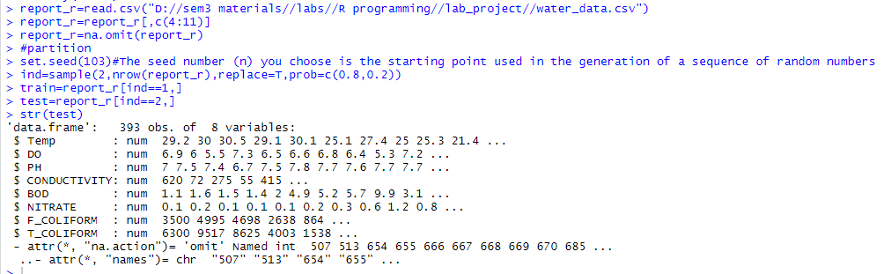

Ridge Model

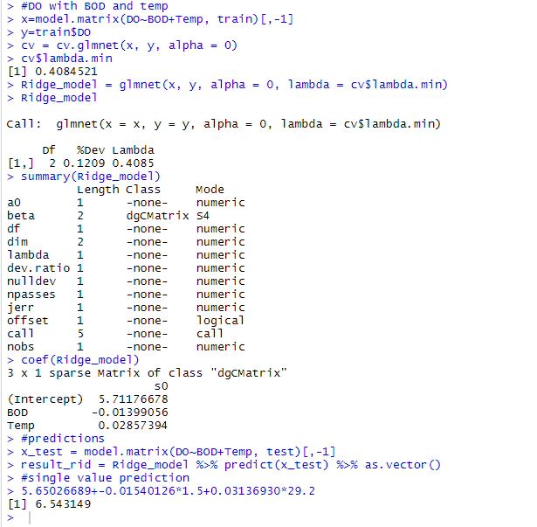

Lasso Model

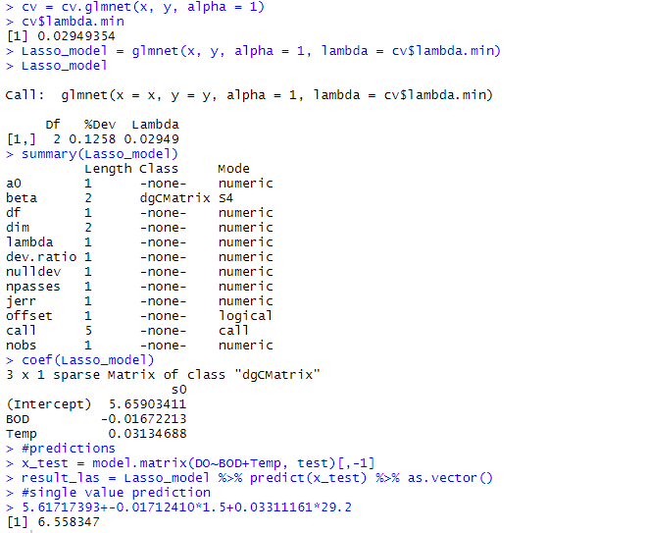

Elastic net Model

